What is piggybacking?
Piggybacking is a cybersecurity term for using a wireless network without the authorization of its administrators.
If a Wi-Fi network has not been protected with a password, anyone who is physically within wireless range of the router can connect to it. Doing so without permission is called piggybacking.
A common example of piggybacking involves people connecting to the Wi-Fi of a business — a coffee shop, for example — without the knowledge or permission of the owners. This often happens if the Wi-Fi can be accessed from outside of the premises (in a nearby apartment, for example, or a neighboring business).

How does piggybacking work?
Before engaging in piggybacking, the perpetrator needs to be physically close enough to the network router to connect their device.
Once they are nearby, the network name will appear on their device’s list of available networks. At this point, there are two ways in which they can access the wireless connection.
If the network has not been protected with a password, the piggybacker can connect right away. This is the most common form of piggybacking. Alternatively, if a password is needed to connect, the perpetrator can either guess the password or find this information out before accessing the network.
It should be noted, however, that the term is also used in an entirely separate area of computing, which we will cover now.

Piggybacking and bandwidth
The term piggybacking is also used to describe a process in which data is transferred more efficiently across a computer network, using minimal channel bandwidth.
When two devices are communicating across a network, data is sent from one to the other in tiny segments called data frames. A data frame moves along a channel in a process referred to as data transmission.
Imagine that Device A transmits a data frame to Device B. When the outgoing data frame reaches its destination, Device B sends an acknowledgement back to Device A to confirm that the transmission was a success. Then, after acknowledgement, Device B sends its own data frames back to Device A, which then acknowledges them, and so on.
Piggybacking in this context means attaching acknowledgement to whatever data packet Device B is going to send back to Device A. Instead of using a separate transmission, the acknowledgement is bundled in with the next data frame. When combined with full duplex transmission, this process maximizes available channel bandwidth and improves efficiency on computer networks.
This type of piggybacking has nothing to do with unauthorized Wi-Fi access, so it is important to distinguish between these definitions. Piggybacking also has a third meaning, which again is unrelated to authorized Wi-Fi access: piggybacking as a means of entry to a physical location.

dumpster diving


By
- Gavin Wright

What is dumpster diving?
Dumpster diving is looking for treasure in someone else's trash. In the world of information technology (IT), dumpster diving is a technique used to retrieve information that could be used to carry out an attack or gain access to a computer network from disposed items.
Dumpster diving isn't limited to searching through the trash for obvious treasures, such as access codes or passwords written down on sticky notes. Seemingly innocent information, such as a phone list, calendar or organizational chart, can be used to assist an attacker using social engineering techniques to gain access to the network.
To prevent dumpster divers from learning anything valuable from trash, experts recommend that businesses establish a disposal policy where all paper -- including printouts -- is shredded in a cross-cut shredder before being recycled, all storage media is erased and all staff is educated about the danger of untracked trash.
Disposed computer hardware can be a gold mine for attackers. Information can be recovered from storage media, including drives that have been improperly formatted or erased. This includes stored passwords and trusted certificates. Even without the storage media, the equipment may include Trusted Platform Module (TPM) data or other hardware IDs that are trusted by an organization. An attacker may also be able to use the hardware to identify the equipment manufacturer to craft potential exploits.
Medical and personnel records may have legal consequences if not properly disposed of. Documents that contain personally identifiable information (PII) must be destroyed, or the organization could be exposed to breaches and potential fines. For example, in 2010, a medical billing office in Massachusetts was fined $140,000, and in 2014, a medical provider in Kansas City, M.O., was fined $400,000.
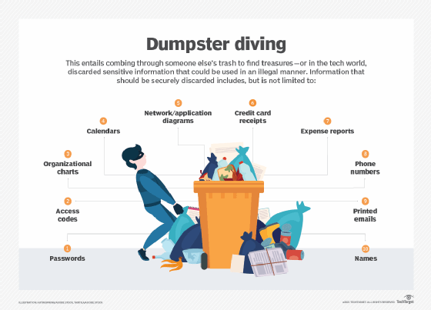

Dumpster diving and social engineering attacks
Social engineering is using human interaction to trick another person into giving access or performing an action for the attacker. A primary goal of social engineering is to establish trust between the attacker and the target. Dumpster diving is a way for attackers to gain information that they use to establish trust. While attackers will also take any computer equipment they find, typically, the primary focus of a dumpster diving attack is to gain information about an organization. Even innocuous documents can be used by an attacker.
A list of names -- such as a directory or phone list -- can be used in many ways by an attacker. Employees' names can be used to guess their computer username, to attack their personal web accounts or for identity theft. A name list can also be used as part of a general phishing campaign against an organization or a spear phishing attack against an executive.
Telephone numbers can be used with caller ID spoofing to coerce an employee to reveal other information in a voice phishing (vishing) attack. An attacker could use this to call an employee with a story like, "Hi, this is John in accounting. The head of finance, Bill, needs some numbers by tonight. I asked Debbie, and she said to talk to you. Can you help me?"
Social engineering attacks use information gathered from dumpster diving. If attackers find a receipt for a vending machine restocking service, they may pretend to be employees of the service with a name badge on the same day and time as an expected delivery to gain access to areas that are not open to the public. Attackers could use this access to do a shoulder surfing attack or install a keylogger to gain access to the network.

How to prevent a dumpster diving attack
Although it may seem like a lot of work to properly care for trash, processes can be put in place to help prevent a dumpster diving attack. These should be documented and clearly explained to employees.
- Have a documented equipment decommissioning process. Ensure all identifiable information is removed from computer equipment before it is disposed of or sold. This includes securely erasing data from hard drives and clearing TPM data. Remove any trust factors in organizational databases, such as domain trust relationships, media access control (MAC) address authentication or expiring trust certificates.
- Use the appropriate secure storage media deletion process. This may include securely erasing disk drives, shredding compact discs (CDs) and degaussing magnetic storage.
- Have a data retention policy, and use certificates of destruction for sensitive data. Data retention policies should state how long documents and data should be kept and how they should be discarded. A certificate of destruction should be created and filed for legal tracking.
- Make shredding convenient. Provide easy access to shredders next to recycling bins, or use secure shred bins next to every trash can. For employees who work from home, provide home paper shredders.
- Educate employees. Provide information on proper disposal and typical social engineering methods. Do not allow employees to take printouts home, and do not give old computer equipment to employees.
- Secure trash. Use locked trash and recycling bins, or keep refuse in a secure area until it is ready to be picked up. Use trusted equipment recyclers.

Shoulder Surfing

What is a Shoulder Surfing Attack?
A shoulder surfing attack describes a situation where the attacker can physically view the device screen and keypad to obtain personal information. It is one of the few attack methods requiring the attacker to be physically close to the victim to succeed.
While it might be as simple as looking over the victim’s shoulder as the name suggests, some attackers will use binoculars, miniature video cameras, or other optical devices to spy on their victims. The goal is to obtain information such as usernames and passwords, personally identifiable or sensitive information, and credit card numbers.
While most shoulder surfing attacks will occur with malicious intent, some might result from nosy people, where it is more an invasion of privacy.

How a Shoulder Surfing Attack Works
Most shoulder surfing attacks are straightforward: the attacker positions himself so that they can view the victim’s device screen and the keyboard or keypad if necessary. As the victim enters and views information on the device, the attacker records this data.
The attacker is likely writing or typing the information somewhere in an equally straightforward manner. Still, more sophisticated attacks may use optical devices, so they don’t need to be looking over the victim’s shoulder and aren’t as easily detected.
An attack where the user has installed some kind of reading device to steal information (such as a skim reader on an ATM) or attacks where the hacker can view your screen, and your entries are not shoulder surfing attacks, since these attacks happen remotely.

Examples of Shoulder Surfing Attacks
Some real-world examples of shoulder surfing including:
- While you were using an ATM, someone positioned themselves in such a way that allowed them to watch you enter your PIN. In a rush, you leave the ATM with your card and money without making sure it had exited entirely out of your account. If the ATM doesn’t require the card to be inserted for the entire transaction, other transactions are permitted if you don’t confirm that you have any other transactions to make as long as the attacker knows the PIN.
- Crowded public transit makes it easy for attackers to see the device screens of others or hear conversations of others. In these cases, they’re literally looking over the victim’s shoulder.
- The victim accidentally leaves their device unattended in a public place. Having watched the victim enter his password into their computer just moments before, the attacker can unlock the device with this information, putting any sensitive data on the computer at risk.

How to Protect Yourself from Shoulder Surfing Attacks
- Eliminate passwords: The ONLY way to ensure the prevention of password-based attacks is through eliminating passwords. Learn more about passwordless authentication today and keep your most critical applications secure.
- Add a privacy screen to your devices: Using devices with attached privacy screens dramatically lessens the risk of data disclosure. Some glass protector manufacturers have versions with a privacy screen included, which not only protects your phone’s glass but the information on your phone, too.
- Always be aware of your surroundings: In public places, don’t let your guard down. Attackers gravitate to those that they see as the easiest. If you’re distracted, you may not notice someone is watching you and what you’re entering into the device or the ATM.
- Use biometric authentication instead: Biometric authentication, either using your fingerprint or face, can offer additional security that a PIN cannot. Since the attacker never sees you enter a physical PIN, they can’t log into the device.
With digital attacks so much more common, shoulder surfing and other similar attacks might not be something you’d think about when thinking about digital security. But it does happen, and staying aware of your surroundings and who’s watching is key to stopping it.

Biometrics - Quick Guide

Biometrics Overview
The term Biometrics is composed of two words − Bio (Greek word for Life) and Metrics (Measurements). Biometrics is a branch of information technology that aims towards establishing one’s identity based on personal traits.
Biometrics is presently a buzzword in the domain of information security as it provides high degree of accuracy in identifying an individual.

What is Biometrics?
Biometrics is a technology used to identify, analyze, and measure an individual’s physical and behavioral characteristics.
Each human being is unique in terms of characteristics, which make him or her different from all others. The physical attributes such as finger prints, color of iris, color of hair, hand geometry, and behavioral characteristics such as tone and accent of speech, signature, or the way of typing keys of computer keyboard etc., make a person stand separate from the rest.
This uniqueness of a person is then used by the biometric systems to −
- Identify and verify a person.
- Authenticate a person to give appropriate rights of system operations.
- Keep the system safe from unethical handling.

What is a Biometric System?
A biometric system is a technology which takes an individual’s physiological, behavioral, or both traits as input, analyzes it, and identifies the individual as a genuine or malicious user.
different.

Authentication (Identification)
This process tries to find out answer of question, “Are you the same who you are claiming to be?”, or, “Do I know you?” This is one-to-many matching and comparison of a person’s biometrics with the whole database.

Verification
This is the one-to-one process of matching where live sample entered by the candidate is compared with a previously stored template in the database. If both are matching with more than 70% agreeable similarity, then the verification is successful.

Authorization
It is the process of assigning access rights to the authenticated or verified users. It tries to find out the answer for the question, “Are you eligible to have certain rights to access this resource?”

Basic Components of a Biometric System
In general, a biometric system can be divided into four basic components. Let us see them briefly −
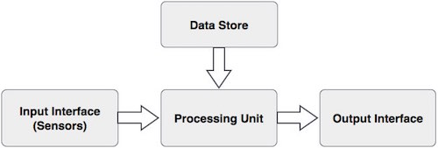

Input Interface (Sensors)
It is the sensing component of a biometrics system that converts human biological data into digital form.
For example,
- A Metal Oxide Semiconductor (CMOS) imager or a Charge Coupled Device (CCD) in the case of face recognition, handprint recognition, or iris/retinal recognition systems.
- An optical sensor in case of fingerprint systems.
- A microphone in case of voice recognition systems.

Processing Unit
The processing component is a microprocessor, Digital Signal Processor (DSP), or computer that processes the data captured from the sensors.
The processing of the biometric sample involves −
- Sample image enhancement
- Sample image normalization
- Feature extraction
- Comparison of the biometric sample with all stored samples in database.

Database Store
The database stores the enrolled sample, which is recalled to perform a match at the time of authentication. For identification, there can be any memory from Random Access Memory (RAM), flash EPROM, or a data server. For verification, a removable storage element like a contact or contactless smart card is used.

Output Interface
The output interface communicates the decision of the biometric system to enable the access to the user. This can be a simple serial communication protocol RS232, or the higher bandwidth USB protocol. It could also be TCP/IP protocol, Radio Frequency Identification (RFID), Bluetooth, or one of the many cellular protocols.

General Working of a Biometric System
There are four general steps a biometric system takes to perform identification and verification −
- Acquire live sample from candidate. (using sensors)
- Extract prominent features from sample. (using processing unit)
- Compare live sample with samples stored in database. (using algorithms)
- Present the decision. (Accept or reject the candidate.)
The biometric sample is acquired from candidate user. The prominent features are extracted from the sample and it is then compared with all the samples stored in the database. When the input sample matches with one of the samples in the database, the biometric system allows the person to access the resources; otherwise prohibits.
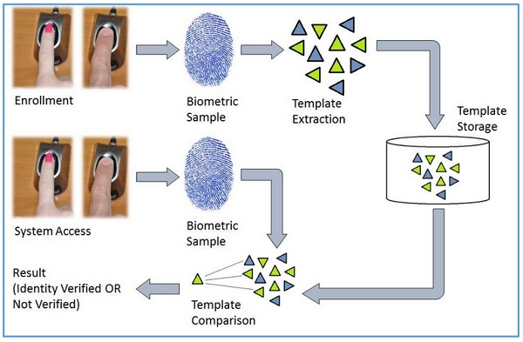

Fingerprint Recognition System
It is the most known and used biometrics solution to authenticate people on biometric systems. The reasons for it being so popular are there are ten available sources of biometric and ease of acquisition.
Every person has a unique fingerprint which is composed of ridges, grooves, and direction of the lines. There are three basic patterns of ridges namely, arch, loop, and whorl. The uniqueness of fingerprint is determined by these features as well as minutiae features such as bifurcation and spots (ridge endings).
Fingerprint is one of oldest and most popular recognition technique. Fingerprint matching techniques are of three types −
- Minutiae Based Techniques − In these minutiae points are found and then mapped to their relative position on finger. There are some difficulties such as if image is of low quality, then it is difficult to find minutiae points correctly. Another difficulty is, it considers local position of ridges and furrows; not global.
- Correlation Based Method − It uses richer gray scale information. It overcomes problems of minutiae-based method, by being able to work with bad quality data. But it has some of its own problems like localization of points.
- Pattern Based (Image Based) Matching − Pattern based algorithms compare the basic fingerprint patterns (arch, whorl, and loop) between a stored template and a candidate fingerprint.
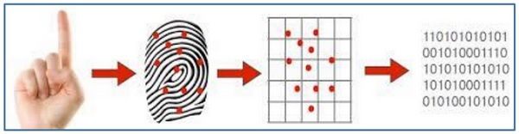

Merits of Finger Recognition System
- It is the most contemporary method.
- It is most economical method.
- It is highly reliable and secure.
- It works on a small template size, which speeds up the verifying process.
- It consumes less memory space.

Demerits of Finger Recognition System
- Scars, cuts or absence of finger can hinder the recognition process.
- The systems can be fooled by using artificial finger made of wax.
- It involves physical contact with the system.
- They leave the pattern of finger behind at the time of entering sample.

Applications of Finger Recognition System
- Verification of driver-license authenticity.
- Checking validity of driving license.
- Border Control/Visa Issuance.
- Access control in organizations.

Hand Geometry Recognition System
It includes measuring length and width of palm, surface area, length and position of fingers, and overall bone structure of the hand. A person’s hand is unique and can be used to identify a person from others. There are two Hand Geometry systems −
- Contact Based − a hand is placed on a scanner’s surface. This placement is positioned by five pins, which guide the candidate hand to position correctly for the camera.
- Contact Less − In this approach neither pins nor platform are required for hand image acquisition.
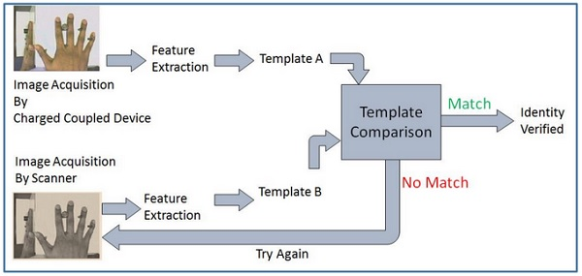

Merits of Hand Geometry Recognition System
- It is sturdy and user friendly.
- The changes in skin moisture or texture do not affect the result.

Demerits of Hand Geometry Recognition System
- Since the hand geometry is not unique, it is not very reliable.
- It is effective in case of adults and not for the growing children.
- If candidate’s hand is with jewelry, plaster, or arthritis, it is likely to introduce a problem.

Applications of Hand Geometry Recognition System
- Nuclear power plants and military use Hand Geometry Recognition for access control.

Retinal Scanning System
Retina is the lining layer at the back of the eyeball that covers 65% of the eyeball’s inner surface. It contains photosensitive cells. Each person’s retina is unique due to the complex network of blood vessels that supply blood.
It is a reliable biometric as the retina pattern remains unchanged throughout the person’s life, barring the patterns of persons having diabetes, glaucoma, or some degenerative disorders.
In retinal scanning process, a person is asked to remove lenses or eyeglasses. A low-intensity infrared light beam is casted into a person’s eye for 10 to 15 seconds. This infrared light is absorbed by the blood vessels forming a pattern of blood vessels during the scan. This pattern is then digitized and stored in the database.
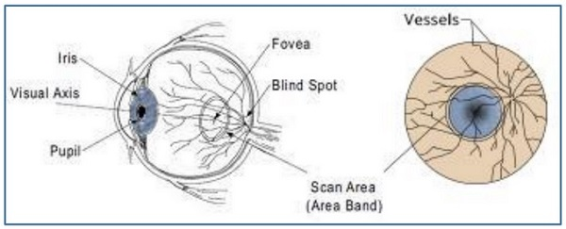

Merits of Retinal Scanning System
- It cannot be forged.
- It is highly reliable as the error rate is 1 out of a crore samples (which is almost 0%).

Demerits of Retinal Scanning System
- It is not very user friendly as the user needs to maintain steadiness that can cause discomfort.
- It tends to reveal some poor health conditions such as hypertension or diabetes, which causes privacy issues.
- Accuracy of the results is prone to diseases such as cataracts, glaucoma, diabetes, etc.

Applications of Retinal Scanning System
- It is practiced by some government bodies such as CID, FBI, etc.
- Apart from security applications, it is also used for ophthalmological diagnostics.

Signature Recognition System
In this case, more emphasis is given on the behavioral patterns in which the signature is signed than the way a signature looks in terms of graphics.
The behavioral patterns include the changes in the timing of writing, pauses, pressure, direction of strokes, and speed during the course of signing. It could be easy to duplicate the graphical appearance of the signature but it is not easy to imitate the signature with the same behavior the person shows while signing.
This technology consists of a pen and a specialized writing tablet, both connected to a computer for template comparison and verification. A high quality tablet can capture the behavioral traits such as speed, pressure, and timing while signing.
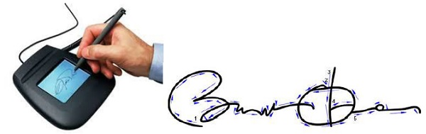
During enrollment phase, the candidate must sign on the writing tablet multiple times for data acquisition. The signature recognition algorithms then extracts the unique features such as timing, pressure, speed, direction of strokes, important points on the path of signature, and the size of signature. The algorithm assigns different values of weights to those points.
At the time of identification, the candidate enters the live sample of the signature, which is compared with the signatures in the database.

Constraints of Signature Recognition System
- To acquire adequate amount of data, the signature should be small enough to fit on tablet and big enough to be able to deal with.
- The quality of the writing tablet decides the robustness of signature recognition enrollment template.
- The candidate must perform the verification processes in the same type of environment and conditions as they were at the time of enrollment. If there is a change, then the enrollment template and live sample template may differ from each other.

Merits of Signature Recognition System
- Signature recognition process has a high resistance to imposters as it is very difficult to imitate the behavior patterns associated with the signature.
- It works very well in high amount business transactions. For example, Signature recognition could be used to positively verify the business representatives involved in the transaction before any classified documents are opened and signed.
- It is a non-invasive tool.
- We all use our signature in some sort of commerce, and thus there are virtually no privacy rights issues involved.
- Even if the system is hacked and the template is stolen, it is easy to restore the template.

Demerits of Signature Recognition System
- The live sample template is prone to change with respect to the changes in behavior while signing. For example, signing with a hand held in plaster.
- User need to get accustomed of using signing tablet. Error rate is high till it happens.

Applications of Signature Recognition System
- It is used in document verification and authorization.
- The Chase Manhattan Bank, Chicago is known as the first bank to adopt Signature Recognition technology.

Keystroke Recognition System
During the World War II, a technique known as Fist of the Sender was used by military intelligence to determine if the Morse code was sent by enemy or ally based on the rhythm of typing. These days, keystroke dynamics the easiest biometric solution to implement in terms of hardware.
This biometric analyzes candidate’s typing pattern, the rhythm, and the speed of typing on a keyboard. The dwell time and flight time measurements are used in keystroke recognition.
Dwell time − It is the duration of time for which a key is pressed.
Flight time − It is the time elapsed between releasing a key and pressing the following key.
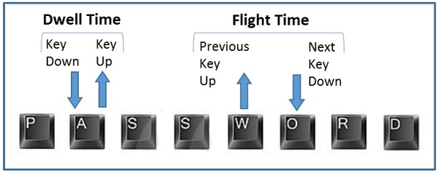
The candidates differ in the way they type on the keyboard as the time they take to find the right key, the flight time, and the dwelling time. Their speed and rhythm of typing also varies according to their level of comfort with the keyboard. Keystroke recognition system monitors the keyboard inputs thousands of times per second in a single attempt to identify users based on their habits of typing.
There are two types of keystroke recognition −
- Static − It is one time recognition at the start of interaction.
- Continuous − It is throughout the course of interaction.

Application of Keystroke Dynamics
- Keystroke Recognition is used for identification/verification. It is used with user ID/password as a form of multifactor authentication.
- It is used for surveillance. Some software solutions track keystroke behavior for each user account without end-user’s knowledge. This tracking is used to analyze if the account was being shared or used by anyone else than the genuine account owner. It is used to verify if some software license is being shared.

Merits of Keystroke Recognition System
- It needs no special hardware to track this biometric.
- It is a quick and secure way of identification.
- A person typing does not have to worry about being watched.
- Users need no training for enrollment or entering their live samples.

Demerits of Keystroke Recognition System
- The candidate’s typing rhythm can change between a number of days or within a day itself because of tiredness, sickness, influence of medicines or alcohol, change of keyboard, etc.
- There are no known features dedicated solely to carry out discriminating information.

Voice Recognition
Voice recognition biometric modality is a combination of both physiological and behavioral modalities. Voice recognition is nothing but sound recognition. It relies on features influenced by −
- Physiological Component − Physical shape, size, and health of a person’s vocal cord, and lips, teeth, tongue, and mouth cavity.
- Behavioral Component − Emotional status of the person while speaking, accents, tone, pitch, pace of talking, mumbling, etc.

Voice Recognition System
Voice Recognition is also called Speaker Recognition. At the time of enrollment, the user needs to speak a word or phrase into a microphone. This is necessary to acquire speech sample of a candidate.
The electrical signal from the microphone is converted into digital signal by an Analog to Digital (ADC) converter. It is recorded into the computer memory as a digitized sample. The computer then compares and attempts to match the input voice of candidate with the stored digitized voice sample and identifies the candidate.
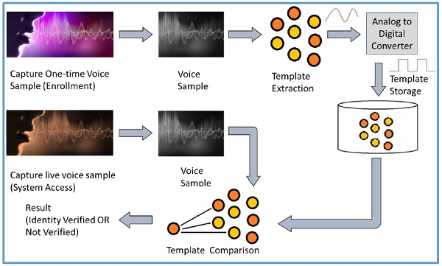

Voice Recognition Modalities
There are two variants of voice recognition − speaker dependent and speaker independent.
Speaker dependent voice recognition relies on the knowledge of candidate's particular voice characteristics. This system learns those characteristics through voice training (or enrollment).
- The system needs to be trained on the users to accustom it to a particular accent and tone before employing to recognize what was said.
- It is a good option if there is only one user going to use the system.
Speaker independent systems are able to recognize the speech from different users by restricting the contexts of the speech such as words and phrases. These systems are used for automated telephone interfaces.
- They do not require training the system on each individual user.
- They are a good choice to be used by different individuals where it is not required to recognize each candidate’s speech characteristics.

Difference between Voice and Speech Recognition
Speaker recognition and Speech recognition are mistakenly taken as same; but they are different technologies. Let us see, how −
Speaker Recognition (Voice Recognition) | Speech Recognition
The objective of voice recognition is to recognize WHO is speaking. | The speech recognition aims at understanding and comprehending WHAT was spoken.
It is used to identify a person by analyzing its tone, voice pitch, and accent. | It is used in hand-free computing, map, or menu navigation.

Merits of Voice Recognition
- It is easy to implement.

Demerits of Voice Recognition
- It is susceptible to quality of microphone and noise.
- The inability to control the factors affecting the input system can significantly decrease performance.
- Some speaker verification systems are also susceptible to spoofing attacks through recorded voice.

Applications of Voice Recognition
- Performing telephone and internet transactions.
- Working with Interactive Voice Response (IRV)-based banking and health systems.
- Applying audio signatures for digital documents.
- In entertainment and emergency services.
- In online education systems.
ccess control is a method of limiting access to a system or to physical or virtual resources. It is a process by which users can access and are granted certain prerogative to systems, resources or information. Access control is a security technique that has control over who can view different aspects, what can be viewed and who can use resources in a computing environment. It is a fundamental concept in security that reduces risk to the business or organization. To establish a secure system, electronic access control systems are used that depend on user credentials, access card readers, auditing and reports to track employee access to restricted business locations and areas. These systems include access control panels to prohibit entry to sensitive areas like alarms and lock down areas to prevent unauthorized access or operations. Access control systems perform identification, authentication, and authorization of users and entities by evaluating required login credentials that may include passwords, pins, bio-metric scans or other authentication factors. There is multi-factor authentication which requires two or more authentication factors which is often an important part of the layered defense to protect access control systems. Authentication Factors:
- Password or PIN
- Bio-metric measurement (fingerprint & retina scan)
- Card or Key
For computer security, access control include the authorization, authentication and audit of the entity trying to gain access. Access control models have a subject and an object.
The Subject-the human user-is the one trying to gain access to the object-usually the software. In computer systems, an access control list contains a list of permissions and the users to whom these permissions apply.
Authentication Mechanism:
- Two-factor authentication
- Multi factor authentication
- one-time password
- Three-factor authentication
- Bio metrics
- Hard Tokens
- Soft Tokens
- Contextual Authentication
- Device identification
Different access control models are used depending on the compliance requirements and the security levels of information technology that is to be protected. Basically access control is of 2 types:
- Physical Access Control: Physical access control restricts entry to campuses, buildings, rooms and physical IT assets.
- Logical Access Control: Logical access control limits connections to computer networks, system files and data.
Access Control Models:
- Attribute-based Access Control (ABAC): In this model, access is granted or declined by evaluating a set of rules, policies, and relationships using the attributes of users, systems and environmental conditions.
- Discretionary Access Control (DAC): In DAC, the owner of data determines who can access specific resources.
- History-Based Access Control (HBAC): Access is granted or declined by evaluating the history of activities of the inquiring party that includes behavior, the time between requests and content of requests.
- Identity-Based Access Control (IBAC): By using this model network administrators can more effectively manage activity and access based on individual requirements.
- Mandatory Access Control (MAC): A control model in which access rights are regulated by a central authority based on multiple levels of security. Security Enhanced Linux is implemented using MAC on the Linux operating system.
- Organization-Based Access control (OrBAC): This model allows the policy designer to define a security policy independently of the implementation.
- Role-Based Access Control (RBAC): RBAC allows access based on the job title. RBAC eliminates discretion on a large scale when providing access to objects. For example, there should not be permissions for human resources specialist to create network accounts.
- Rule-Based Access Control (RAC): RAC method is largely context based. Example of this would be only allowing students to use the labs during a certain time of day.

